**Housekeeping**

Continue to empty folders daily

**Supply Wish List-**

snacks, glue sticks

napkins, small cups,

Thank you to everyone who donated items already!!! I truly appreciate it!

**Conferences**

Thank you to everyone who attended conferences!! It was so nice to see you all!! Thank you for your continued support!!

What We’re Learning!

**Language Arts**

We will continue to work on the whole alphabet. We will discuss that every letter makes a sound. Vowels make two sounds.

**Letter of the week**-Hh **Popcorn Words**-are, do, that

**Text Comprehension Topic** –Sequence

**Genre-**Animal Fantasy

**Amazing Words-**world, lonely, trip, horizon, journey, homesick

**Writing**

Letter formation, tracing and/or copying words to complete a sentence.

**Genre-**Directions

**Math-**addition and subtraction, decomposing numbers to 10

**Focus Topic**

**Question of the week:** What can we learn from our adventures?

Spring

**Special Person of the Week-**Students are randomly chosen each week. They complete the “All About Me Poster” sent home the Friday before and get to share it with the class. They also get to sit in the Special Person Chair all week and have special privilege for the week.

Mrs. Kane’s  
Newsletter

3/30/15-4/3/15

**Email address:** kanek@naugy.net  
**Address:** 140 Andrew Avenue School  
**Phone Number:** 203-720-5221

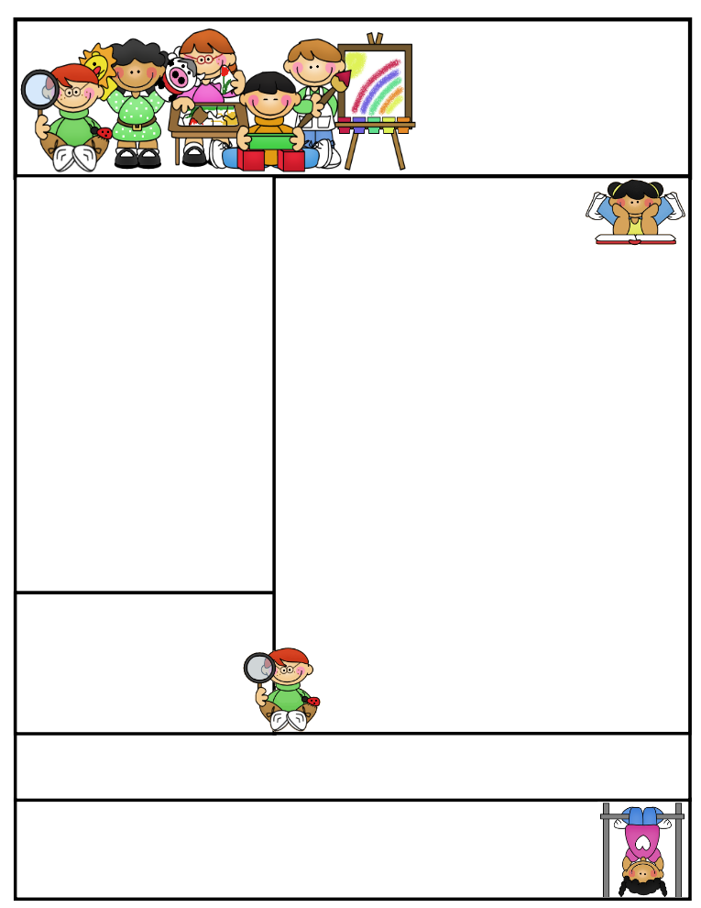

**Parent Volunteers!**

**Please let me know if you are interested in volunteering in the classroom. I am especially looking for volunteers during our center times! Email or write a note if you are interested!**

**Thanks!**

**Lunch and Ice cream Money**

Please put any money you are sending to school in an envelope or baggie with your child’s name clearly printed and labeled with what it is for.

Students get very upset when they lose their money.

**Website**

**I am very excited to announce that our classroom website is up and running!!**

**Please visit it at** [**http://mrskaneskindergarten.weebly.com**](http://mrskaneskindergarten.weebly.com)

**I showed the class and they were very excited!!!**

**Dates To Remember**

**Events:**

**Cupcake Wars: 3/27/15**

**Remember to hand in reading logs**

**Please see the attached letter about snacks and food in the classroom. This a new district policy.**

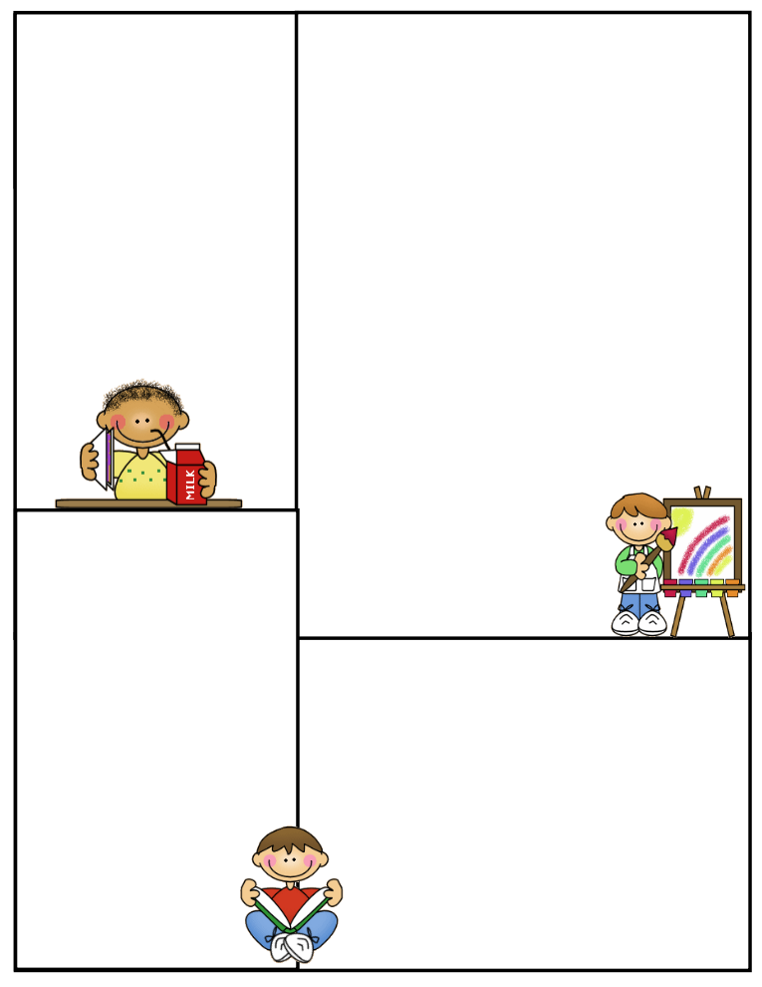

**Newsletter Template**

Customize the newsletter template to meet your classroom needs. Click inside a box to type your information. Change the boxes to whatever you’d like to include!

Visit my blog for more freebies and lesson ideas:

<http://firstgradebrain.blogspot.com>

Visit my TeachersPayTeachers store for more products:

<http://www.teacherspayteachers.com/Store/Mrs-Magee/Products>